Directories Submission:
S.no | URL | 360schooltrips Screenshot
01 | http://www.submission4u.com/submit.php?c=568 | 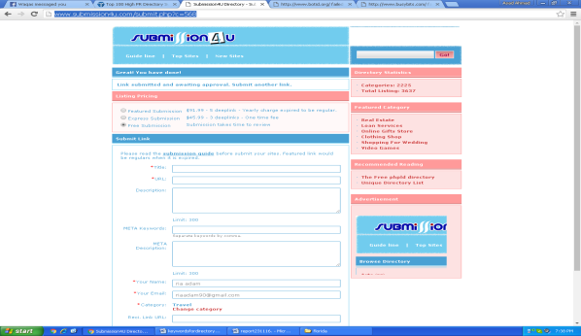
02 | http://www.botid.org/addurl/Submission_Options/default.aspx
03 | http://www.busybits.com/files/addurl.php | 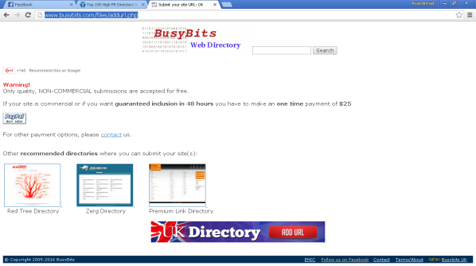
04 | http://www.addbusiness.net/submit.php?c=501&LINK_TYPE=1
05 | http://www.bedwan.com/submit.php?c=733&LINK_TYPE=1 | 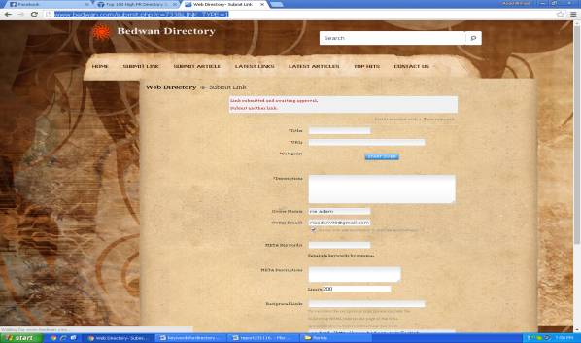
06 | http://www.digabusiness.com/submit.php
07 | http://www.directoryseo.biz/submit.php?c=1&LINK_TYPE=1 | 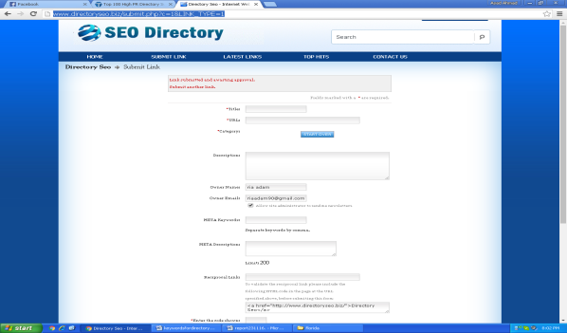
08 | http://www.generalshoppingdirectory.com/submit.php?c=318&LINK_TYPE=9
09 | http://www.h-log.com/submit.php?c=113
10 | http://www.eslovar.com/submit.php?c=1&LINK_TYPE=1 | 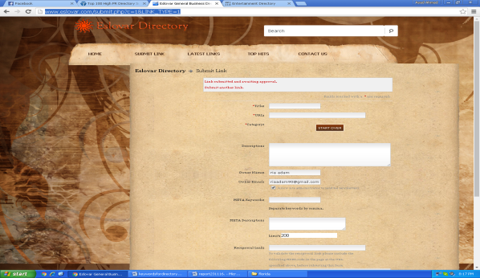
11 | http://www.jewana.com/submit.php?c=2725&LINK_TYPE=1 | 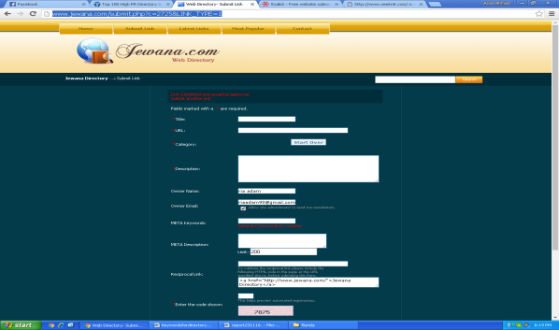
12 | http://www.itzalist.com/cgi-bin/thanks-for-submitting.cgi
13 | http://www.bari.biz/submit.php?c=10&LINK_TYPE=1 | 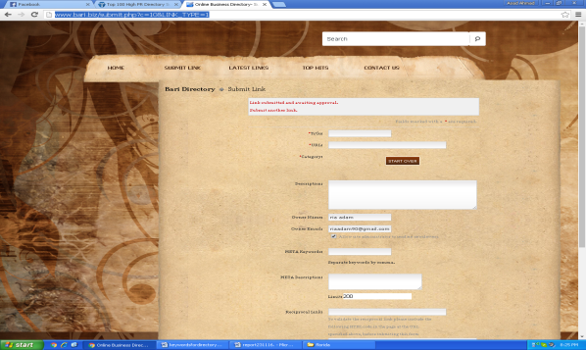
14 | http://wldirectory.com/submit.php | 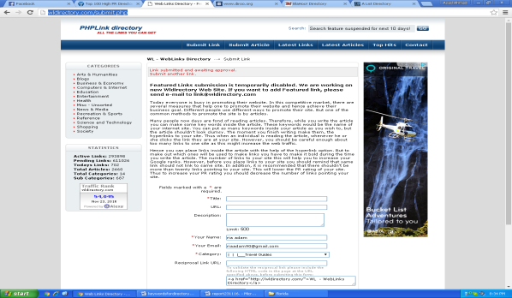
15 | http://www.alistdirectory.com/submit.php | 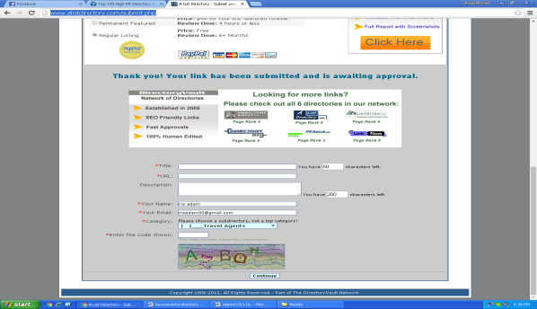
16 | http://www.hydeparkbooks.com/submit.php | 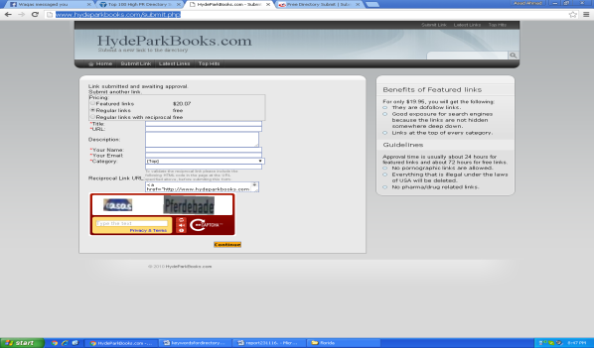
17 | http://www.freedirectorysubmit.com/submit.php
18 | http://www.allstatesusadirectory.com/submit.php | 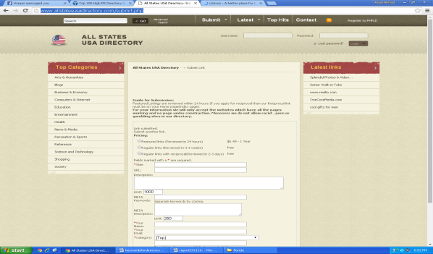
19 | http://www.linkroo.com/submit.php | 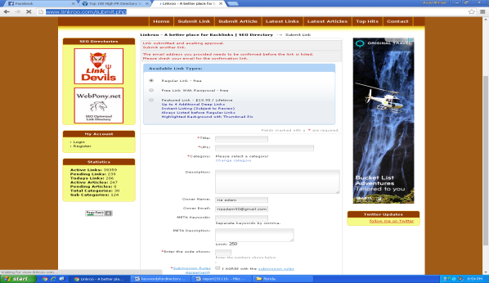
20 | http://www.generalbusinesswebdirectory.com/submit.php?c=24&LINK_TYPE=2 | 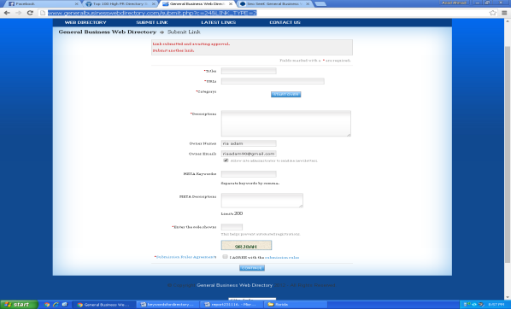
21 | http://www.usawebsitesdirectory.com/submit.php | 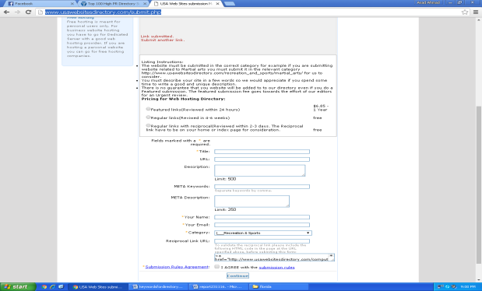
22 | http://www.seodirectoryonline.org/SubmitLink/getSubmitedRes
23 | http://www.freetoprankdirectory.com/submit.php | 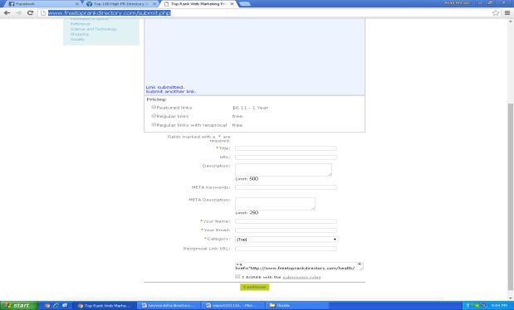
24 | http://www.enforum.net/submit.php?c=667&LINK_TYPE=2 | 